# A PRELIMINARY MINI PROJECT REPORT ON

“SportsAvenue”

SUBMITTED TOWARD PARTIAL FULFILLMENT OF THE REQUIREMENTS FOR SUBJECT: **SKILL DEVELOPMENT LABORATORY** (SEMESTER: 6)

# (T.Y. B.Tech)

Academic Year: 2023-24

Submitted by:

**Pranav Lad** – **TYCOB119**

**Shreyash Kharde** – **TYCOB102**

**Om Kinge – TYCOB108**

Under the Guidance of:

**Prof. CHHAYA NAYAK**



**DEPARTMENT OF COMPUTER ENGINEERING, PIMPRI CHINCHWAD COLLEGE OF ENGINEERING, PUNE**



**PIMPRI CHINCHWAD COLLEGE OF ENGINEERING DEPARTMENT OF**

**COMPUTER ENGINEERING**

**CERTIFICATE**

This is to certify that, the project entitled

**“SportsAvenue”**

is successfully carried out as a mini project successfully submitted by following students of “PCET's Pimpri Chinchwad College of Engineering, Nigdi, Pune-44**”.**

**Under the guidance of**

**Prof. Chhaya Nayak**

In the partial fulfillment of the requirements for the T.Y. B. Tech.

(Computer Engineering)

By:

| **Pranav Lad** | **TYCOB119** |
| --- | --- |
| **Shreyash Kharde** | **TYCOB102** |
| **Om Kinge** | **TYCOB108** |

**Prof.** **Chhaya Nayak**

**Project Guide**

# 1.0 Introduction:

Currently the registration systems of most of the turfs or playing grounds are working manually. Sometimes it becomes difficult to book turf playground because of timing issues or the slot getting booked previously this turf booking software will make booking the turf efficient and easy by avoiding physical walking to the ground or contacting by call. Before starting the development of the project, there are few things that need to be considered first. This is to ensure that the project is feasible to be continued and also at the same time to provide a guideline or standard on how the project works. For that purpose, this section will be giving brief explanations about the project, the identification of problem statements, objectives that need to be achieved and scope of study that need to be followed.

# 2.0 Designing of Website & identifying constraints:

## Problem Statement:

Develop a Sports Avenue website using Html, CSS, JS, SQL, and PHP.

## Motivation:

## The motivation behind a turf booking system is to provide a convenient and efficient way for users to book and reserve turf fields for sports and other recreational activities. By automating the booking process, the system reduces the administrative burden on facility managers and allows users to easily browse available times and book their desired slots.

## Additionally, a turf booking system can help ensure fairness and transparency in the booking process by providing a clear and consistent set of rules and procedures for all users. This can help prevent conflicts and disputes over the scheduling and usage of turf fields.

## Overall, a turf booking system can improve the user experience for both facility managers and users by streamlining the booking process, reducing administrative burden, and promoting fairness and transparency.

## Scope:

**1.User registration and login:** The system should allow users to create a profile and login to their account to make bookings.

**2.User Profile:** User can see their profile on the app which is located on left side of the pag**e.**

**3.Venue management:** The system should allow the venue owner to manage their venue's availability, pricing, and other details.

**4. Booking management:** Users should be able to search for available venues based on location, date, time, and other filters. They should be able to book and pay for the venue through the system.

**5.Payment integration:** The system should integrate with a payment gateway to allow users to pay for their bookings securely.

**6.Admin dashboard:** The system should have an admin dashboard to manage user accounts, venues, bookings, and other details.

**7. Mobile-friendly interface:** The system should have a responsive design to be accessible on mobile devices.

**8. User Feedback and Rating:** Users can share their experiences on the form about turf facilities and rate their services so that turf owner can improve their services in future.

## Software/Services Requirements:

**Hardware Resources:**

● Laptops

● Ethernet

● LAN

**Software Resource:**

● VS code (Editor)

● Chrome (Browser)

● Bootstrap

● Image Compressor

● Canva

**Software Requirement Specification:**

Software Development Life Cycle (SDLC) is a process used by the software industry to design, develop and test high quality software. The SDLC aims to produce high-quality software that meets or exceeds customer expectations, reaches completion within time and cost estimates.

## Technological stack used:

1. HTML
2. CSS
3. Javascript
4. Apache Tomacat Server
5. XAMPP
6. MySQL

# Managing the workflow of the website:

Our software performs the booking and login function with every possible condition tested, when the user is newly visiting the website, the user has poor internet connection, user traffic is very large (around 1000). We also provide with google analytics to our website to easily manage and know about traffic statistics

Online booking system (SportsAvenue) – Modules”

1. Admin Module
2. Instructor Module
3. User Module
4. ADMIN MODULE:

                1. REGISTER

                2. LOGIN

                3. CHANGE PASSWORD & FORGOT PASSWORD

 4. USER - MODIFYING DETAILS

               5. DEPARTMENTS - ENTERING/MODIFYING DETAILS

               6. INSTRUCTOR DETAILS - MODIFYING DETAILS

# 4.0 Building of website:

Every functionality is separated in different components in the angular framework. The website is constantly tested on the Google Chrome browser. The project is built using the Eclipse IDE for Web Developers and Visual Studio Code. The building phase of the project consists of two parts:

1. **Building and testing the front-end**: Primarily built on HTML, CSS, Bootstrap. It defines the skeleton of the website and routes of the web-app.
2. **Building and testing the back-end**: It consists of connecting the database with the web- app using XAMPP and Apache servers. The database handling is most crucial part of back-end development.

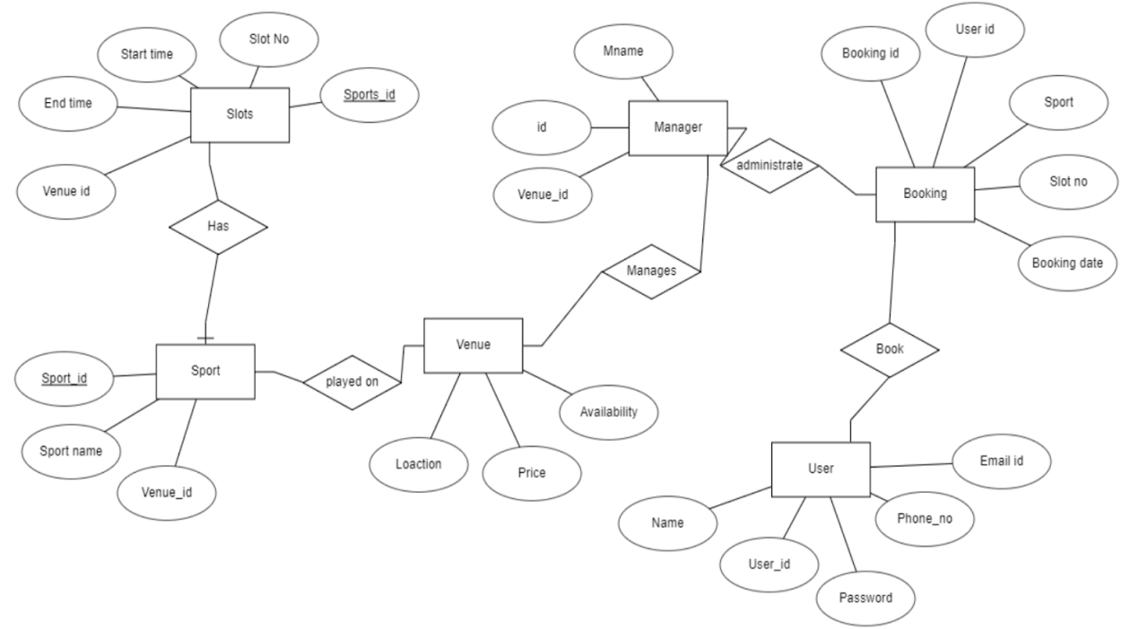

Above is the block diagram of routing structure of the web-app:

5.0 Progress until

As discussed above, a small phase of scope-1 of the project was completed in the previous semester. The same project will be continued and is to be built with MEAN stack model.

Small recap of designs of website from previous work is illustrated below:

**Source Code :** [**https://github.com/pranav-lad/SportsAvenue**](https://github.com/pranav-lad/SportsAvenue)



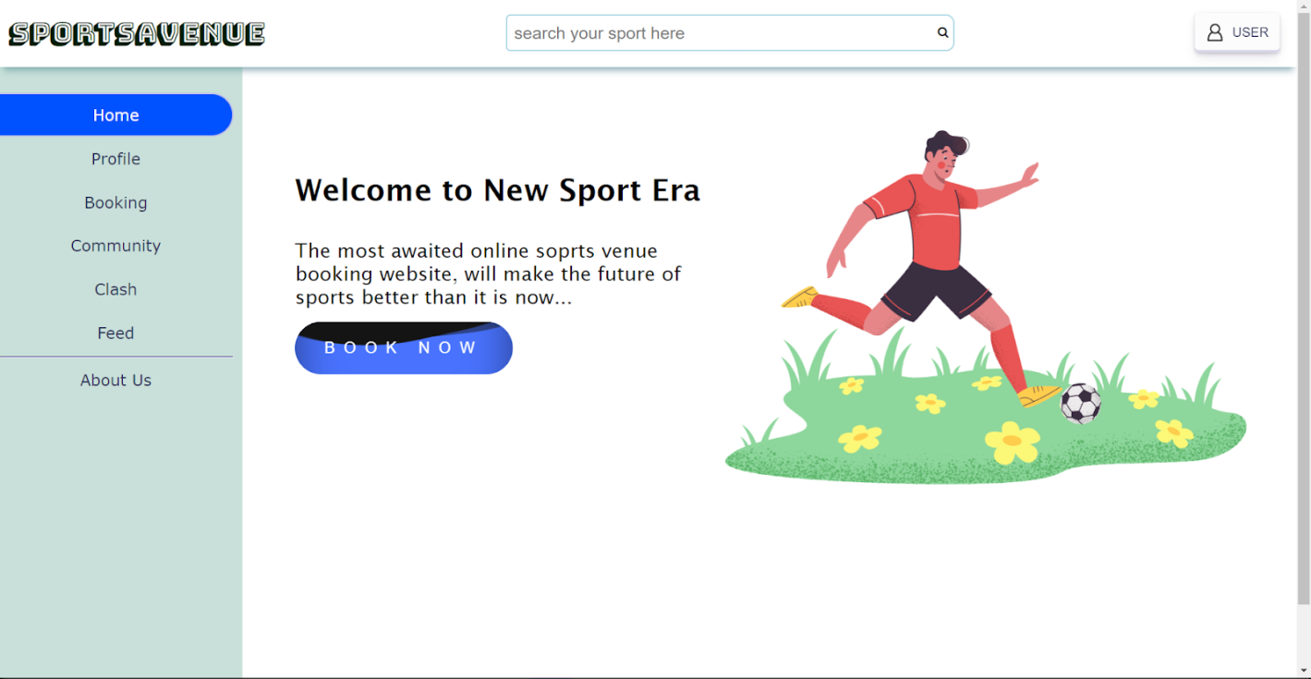

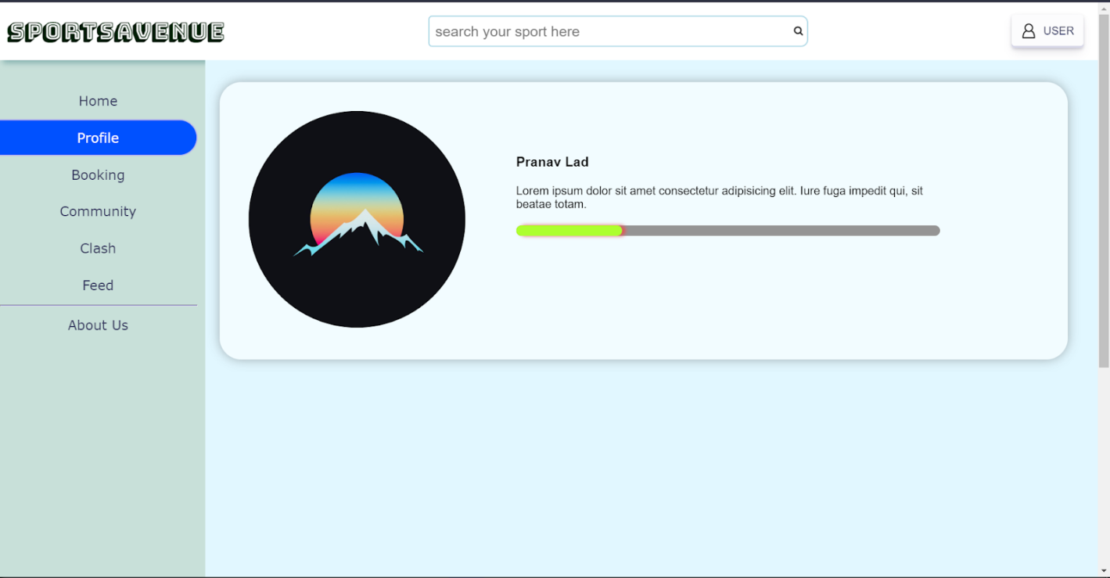

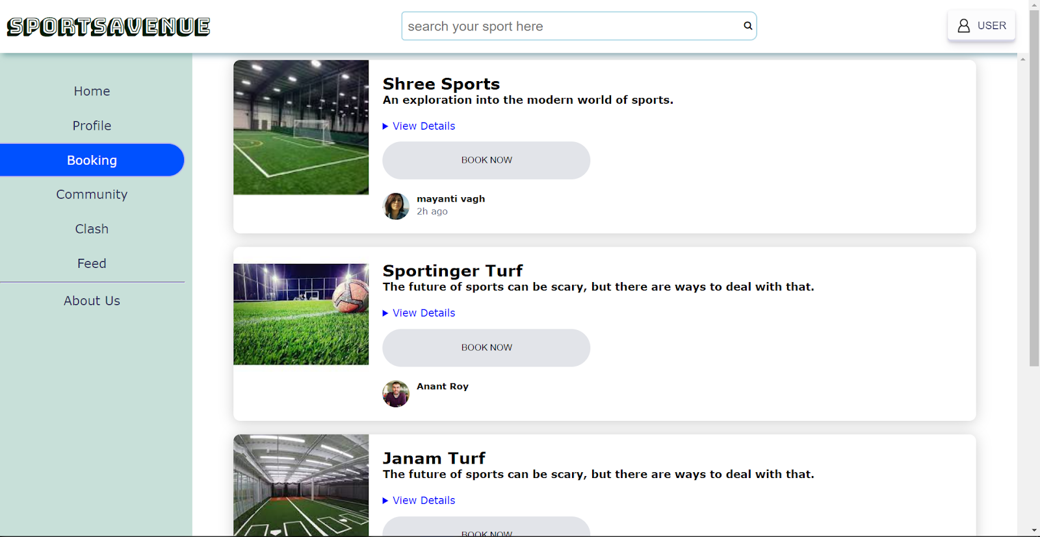

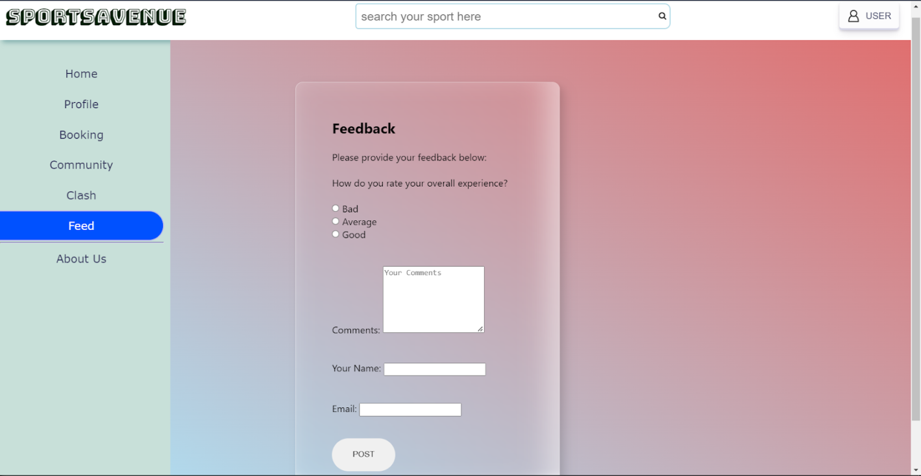

6. **Conclusion:**

Our project can easily be modified according to new trends and user needs with much more device compatibility and updated user experience. The following conclusions can be deduced from the development of the project:

* More users use the software increasing automation of the booking process attracting new users and managers.
* It provides a friendly graphical user interface which proves to be better when compared to the existing system.
* It gives appropriate access to the authorized users depending on their permissions.
* It effectively overcomes the delay in communications and response time is less.
* Updating information becomes easier for users and more efficient.
* System security, data security and reliability are the striking features.
* The System has adequate scope for modification in future if it is necessary.